Addendum 1:

Please see the below changes to the Specification for the American Turnmaster Clausing Colchester Lathe.

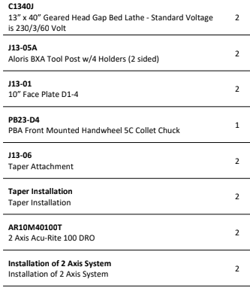

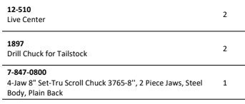

Bid should include Freight, Rigging, and installation.